User Guide for Common Information Requests

Once logged into the system, you will see a list of folders containing the reports available for you to select the one you are interested in:

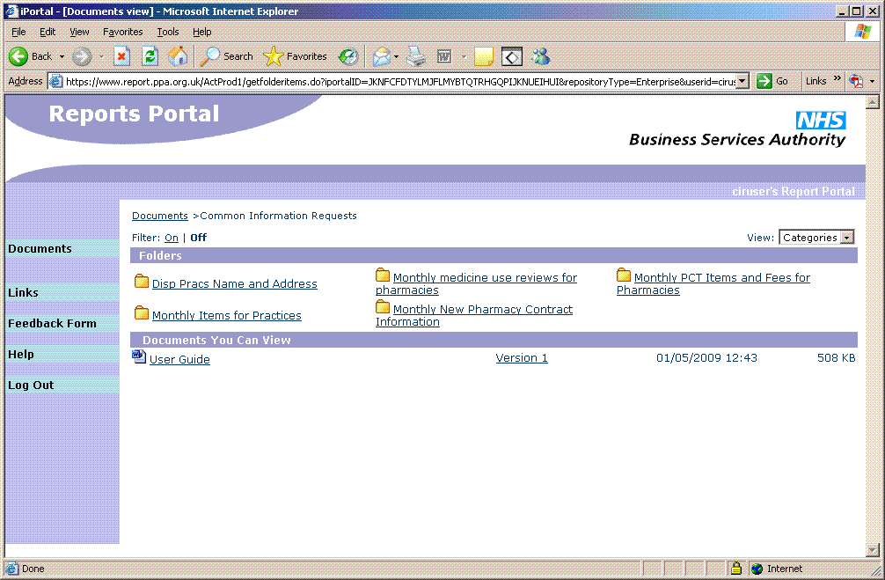

To view the specific report for the period you are interested in select it from the list of ‘Documents You Can View’:

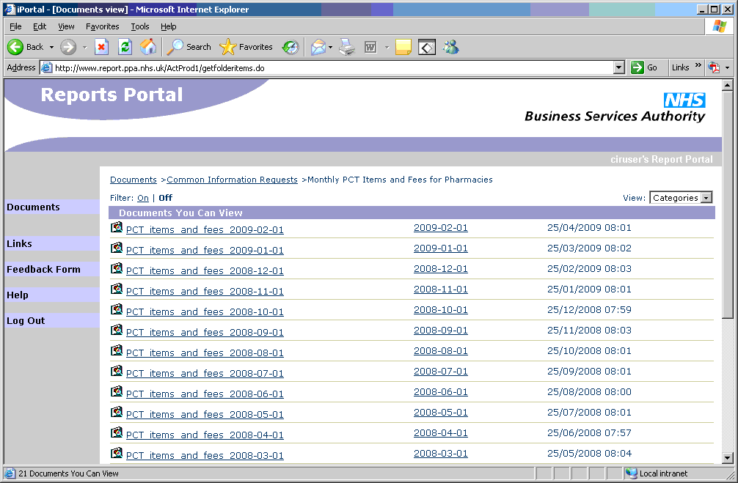

When viewing a report there is a pale blue strip at the top of the screen to allow you to navigate through the pages. You can select Next page, Previous page or to go to a specific page.

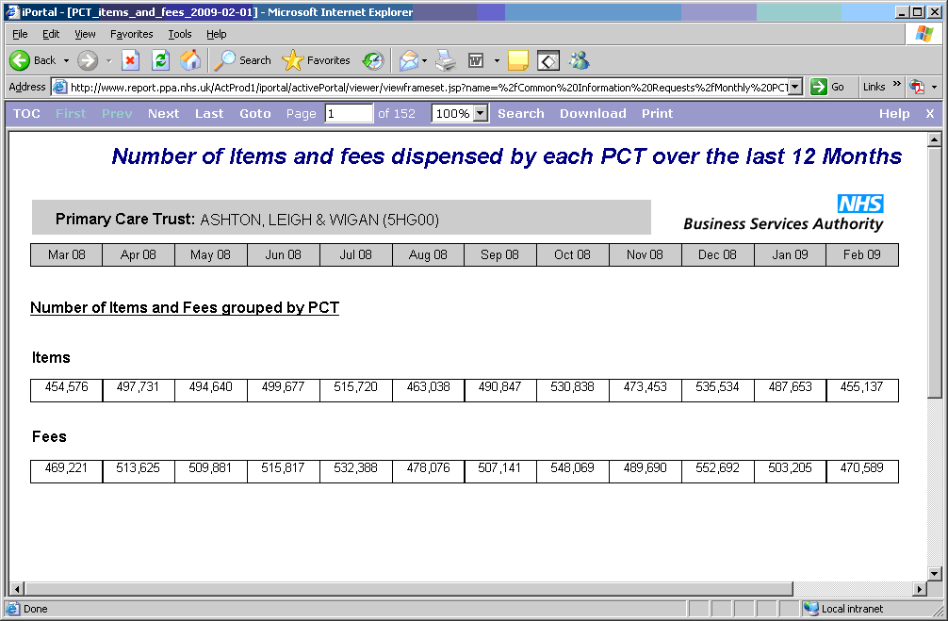

Navigating a report

Whist in the report view, selecting ‘TOC’ from the pale blue toolbar will generate a Table of Contents relevant to that report, in this case, made up of PCTs. Clicking the little blue arrow next to an entry will expand it to show the entries below. If you then select an entry, the report view will jump to the first page for that entry:

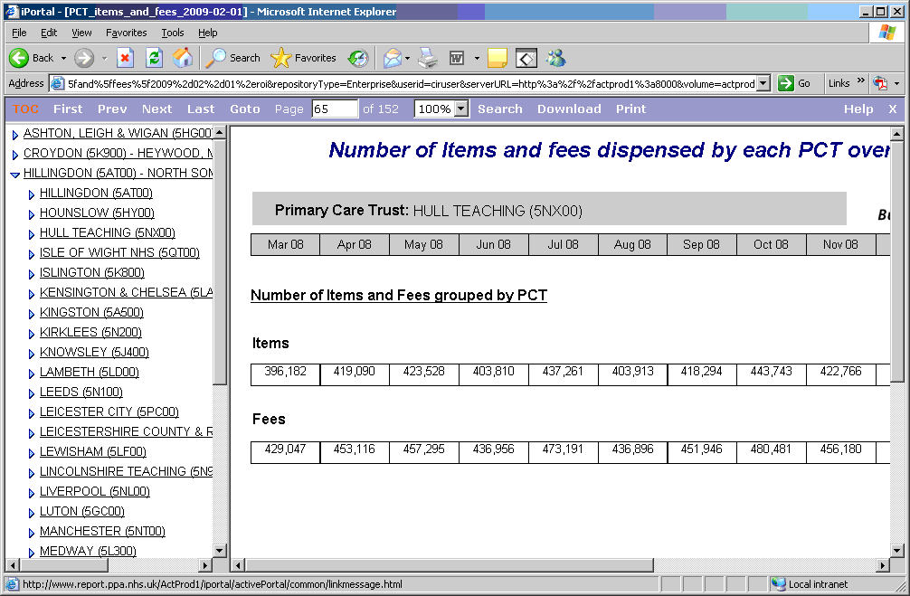

To hide the Table of Contents, click on ‘TOC’ again.

Searching a Report

Whist in the report view, selecting ‘Search’ from the pale blue toolbar will create a Search panel on the left hand side of the screen:

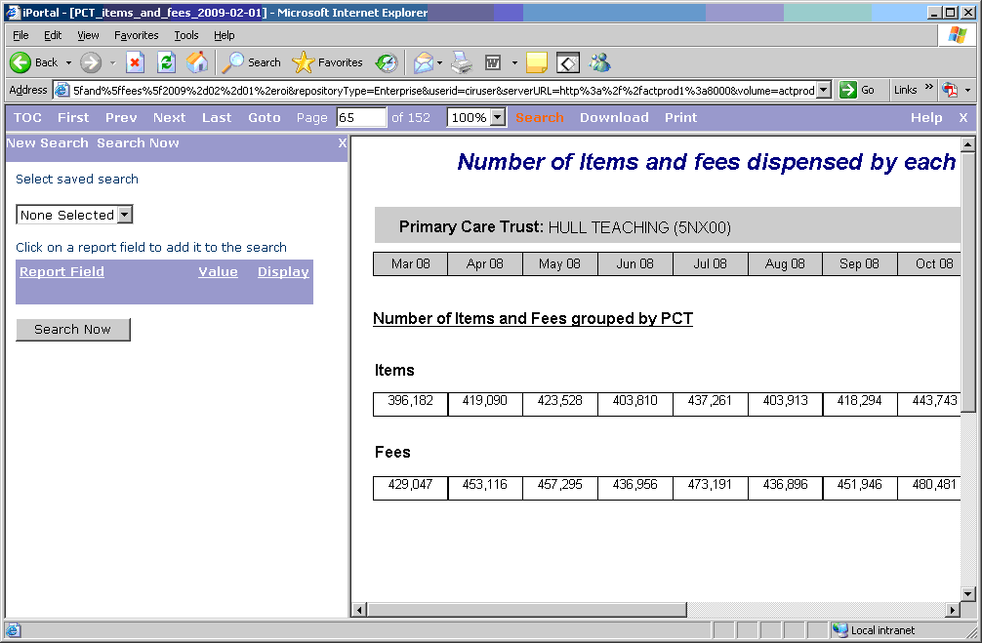

To search on a data item, move the mouse pointer over the data on the report. If it is a searchable item the mouse pointer will change to look like a hand. Click on the item on the report view and it will appear in a list in the search panel on the left. You can select any number of searchable items to combine into a search.

For example, to search for a Primary Care Trust, click on the PCT name on the report view and it will appear in the search panel on the left:

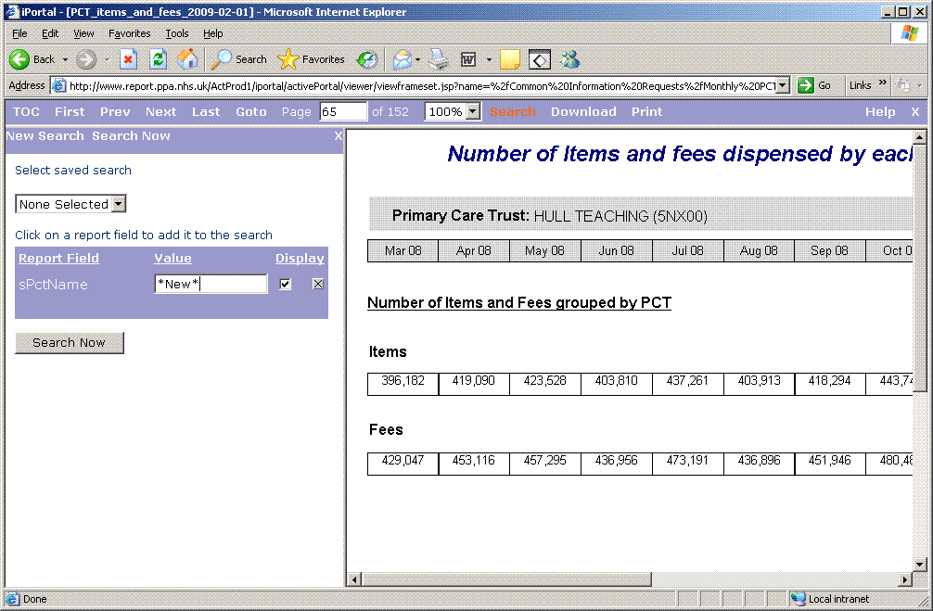

Now, enter your search criteria, surrounded by ‘*’ (in this case *New*), into the search field and click the ‘Search Now’ button.

A list of all incidents of the search criteria will appear in the search panel. Clicking on each of them will jump the report view to the relevant page of the report:

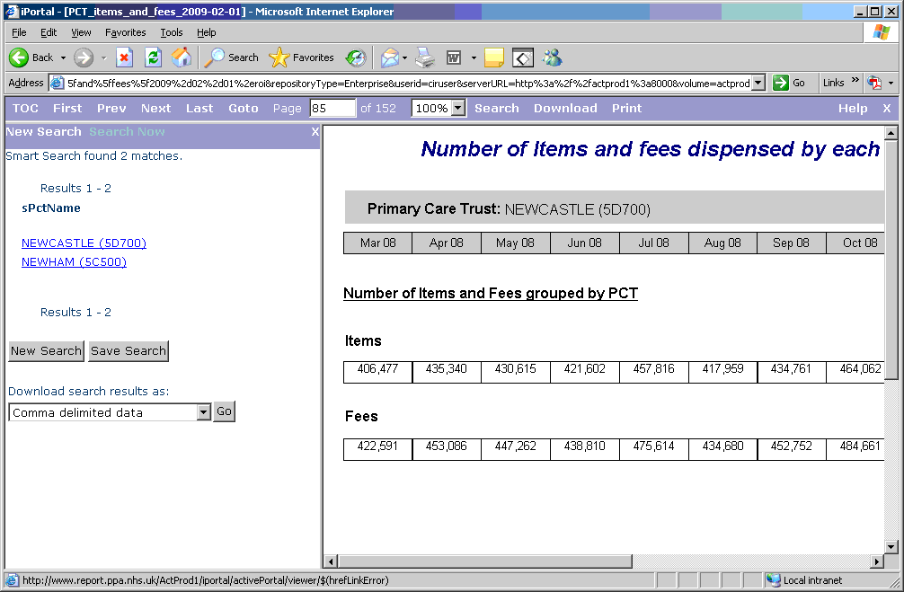

Exporting Data

Whist in the report view, selecting ‘Download’ from the pale blue toolbar will give you the option to download some or all the pages of the report in either PDF or Excel format. The downloaded data will be formatted in PDF or Excel format in the same way as it is on the report viewer screen.

NOTE: Excel downloads using this method are limited to 50 pages per download.

For those reports that have searchable fields, unformatted data can be downloaded easily into Excel extracting just the data that satisfies the search.

To do this you need to do a search and select each data item you want to be exported to Excel and not just the items you need to search on. For example:

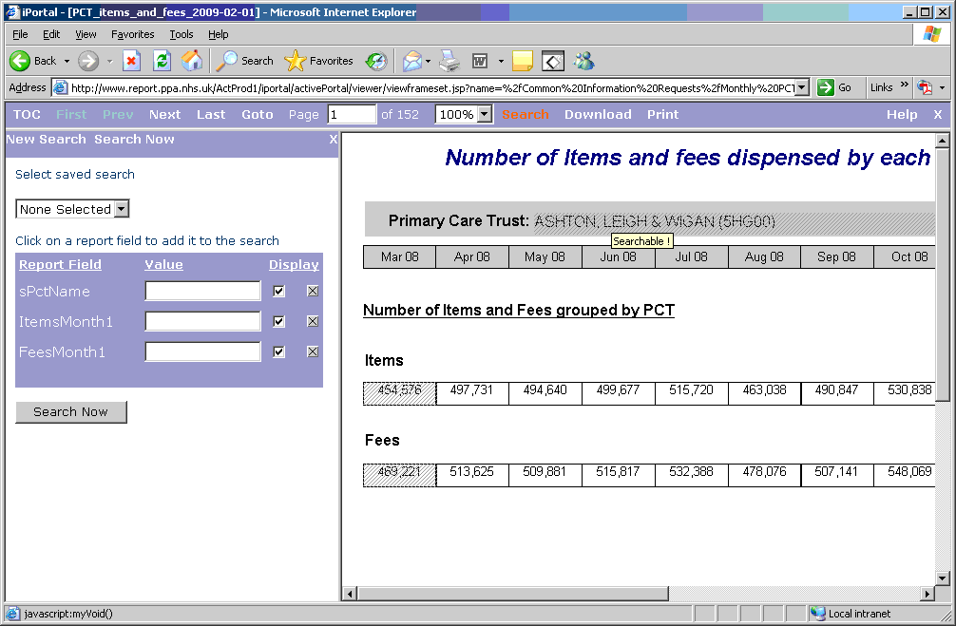

Once the search is complete a list of all the matching data will be produced in the left-hand panel of the screen:

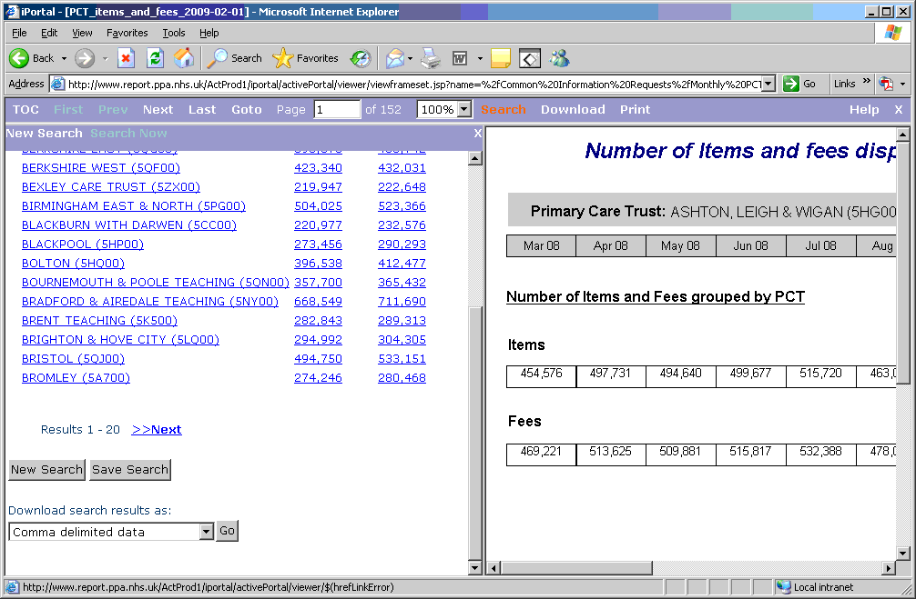

In the 'Download search results as' list at the bottom of the screen, select either 'Comma delimited data' or 'MS Excel file' and click the 'Go' button.

Excel will be launched with the selected data nicely arranged in columns.

